District Level Health Surveys

The Government has conducted District Level Household Surveys (DLHS) during 1998-99 (DLHS-1), 2002-04 (DLHS-2), 2007-08 (DLHS-3) and 2012-13 (DLHS-4). Further, Annual Health Survey (AHS) which also provide district level data was conducted during 2010-11(AHS-1), 2011-12 (AHS-2) and 2012-13 (AHS-3). The AHS was conducted in Assam, Bihar, Chhattisgarh, Jharkhand, Madhya Pradesh, Odisha, Rajasthan, Uttar Pradesh and Uttarakhand.

State-wise key indicators from AHS are given below:

Key Indicators: AHS-1(2010-11), AHS-2(2011-12) and AHS-3(2012-13)

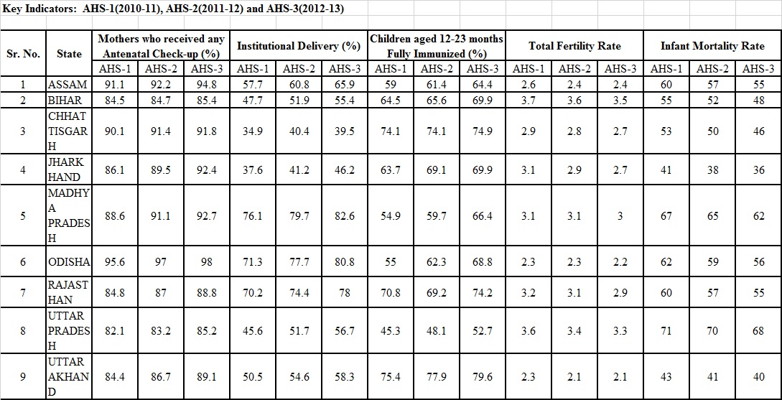
The results of the Surveys have helped in assessing the performance of health sector programmes, planning new schemes / progammes and realigning the existing health schemes. National Rural Health Mission (NRHM) was launched in 2005 to provide accessible, affordable and quality health care to the population, especially the vulnerable groups. Following the success of NRHM, National Urban Health Mission was also lunched and the two Missions have been now subsumed under National Health Mission (NHM). Further, using data from DLHS and AHS, the Ministry has identified 184 High Priority Districts for focused attention on reproductive, maternal, newborn, child and adolescent health.

The Health Minister, Shri J P Nadda stated this in a written reply in the Rajya Sabha here today.

*****

MV/LK

(Release ID :119824)

